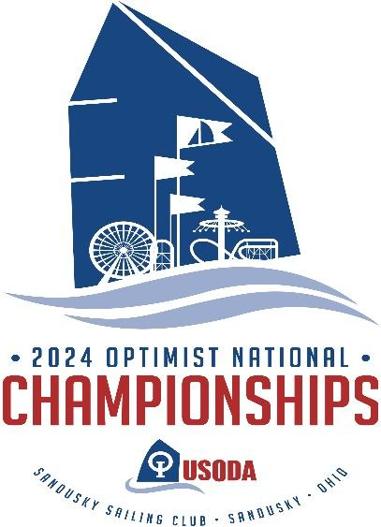

SPONSOR CONTACT FORM
Sponsor Name:

Contact person, title:

Business address:

Contact phone:

Contact email:

Level of Sponsorship desired:

Logo Attached/emailed In JPEG form
Please mail this form by May 1, 2024 to Sandusky Sail Club ℅ Opti Nationals at PO Box 814, Sandusky, Ohio 44870. Please include your check or money order. Alternatively, you may contact Marcia Giordano at 205-903-9256 or marciasvlc@yahoo.com to make other arrangements or secure payment by Credit Card.

