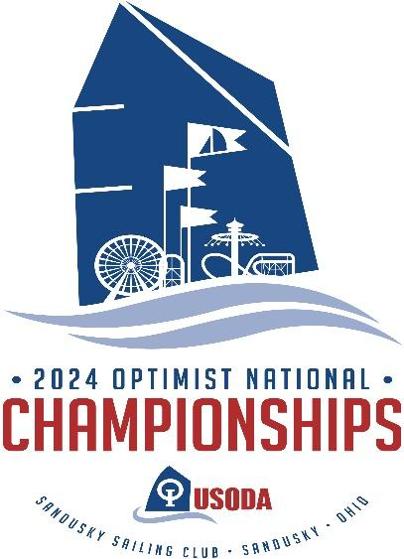

I-LYA CLUB CONTACT FORM
For Silver and Bronze Sponsors ($250- burgee on the Banner. $500- burgee on the Banner and Volunteer shirts)

Full Club Name:

Contact person, title:

Contact phone:

Contact email:

Bronze or Silver Sponsor?:

Burgee Attached/emailed as JPEG file
Please mail this form by May 1, 2024 to Sandusky Sail Club ℅ Opti Nationals at PO Box 814, Sandusky, Ohio 44870. Please include your check or money order. Alternatively, you may contact Marcia Giordano at 205-903-9256 or marciasvlc@yahoo.com to make other arrangements or secure payment by Credit Card.

